GROUP SEVEN: AMERICAN APPAREL – ARGENTINA
Kiley Anderson April 12, 2010
Mary-Kerstin Lindqvist Assignment 11
Hannah Thomas
Samantha Vogt
Cristina Wanamaker

A retailer’s store design and layout are the foundation of its image and success. Although e-tailing is on the rise, the majority of consumers worldwide still prefer to shop at brick-and- mortar locations. American Apparel has established itself as a hip brand with simple, yet intriguing retail stores. Our ideas for the Buenos Aires location are explained below and accompanied by a detailed floor plan.

TARGET MARKET

Our target market includes young men and women ages 18-30 who are fashionable, comfortable with their sex appeal and have middle to upper class incomes. They are high school and college students and young professionals with an eye on the latest trends. They love to wear bright colors and make bold fashion statements.

RETAILER’S IMAGE

We will create a fun and exciting environment in which customers can shop, while keeping the layout and design stylish and simple. We want to keep our store similar to most American Apparel stores, with bright colors, simple fixtures and photographs and advertisements on the walls. This will help maintain a consistent American Apparel store image, yet make it unique from others, having more of a laid-back, beach feel since it is located in Buenos Aires, Argentina.

Although many American Apparel stores are funky and eclectic, we would like to make this Buenos Aires location a bit more sophisticated – while keeping a young, fresh feel. Because the store is located near downtown, but not near other American-based retailers, we want to assure that the store design exudes style and sophistication while still being true to the racy image for which American Apparel is known. Because Argentineans are sophisticated, yet exude sexuality, this concept will be successful.

FLOOR PLAN

This American Apparel store will have a unique floor plan because of the location we have chosen in Argentina. Our store, at Roseti 428, is close to downtown Buenos Aires and just blocks from Palermo Hollywood. We will have to tear down two walls in order to create a more open floor plan. Once we have completed this renovation, we will be able to utilize the 170 square meters (1,829 square feet) of retail floor space as efficiently as possible.

The majority of floor space will constitute the main selling area where all apparel merchandise will be displayed and the fitting rooms and cash wrap are located. Off the left side of this main selling area, an indoor patio (almost like a sun room) will house most of the store’s accessory items, including jewelry, purses, sunglasses, etc. Off of the patio are the employee break room and the restroom.

There will be three fitting rooms available for customers to try on clothing. Each room will contain a modern chair, wall hooks and a full-length mirror. The rooms will be closed off by curtains rather than doors. The curtains offer a soft element in the highly modern layout of the store and also act as an additional decorative element. There is a door to the left of the fitting rooms that leads to the back room/storage area. This is where extra merchandise and fixtures, new shipments, promotional materials and office supplies will be stored.

A seating area is located immediately in front of the fitting rooms. This is convenient for those who are with a friend who is trying on clothing or for those who wish to take a break to relax. Including a seating area promotes customer interaction and creates a relaxed and inviting environment. Because Argentineans are polychronic, relationships are what matter (Argentina–Language, Culture, Customs and Etiquette). Creating a home-like space will make them feel trusting and comfortable. A table with magazines and the latest American Apparel catalog will offer customers entertainment while continuing to promote the store.

The indoor patio is currently separated from the main selling space by a wall. This wall will be removed to open the patio to the main area. By tearing down this wall, lots of light will pour into the entire store through all the windows on the upper walls of the patio area. This space will feature the store’s accessories, and the walls will be painted an aqua blue to set the patio off from the rest of the store. Accessories will be displayed on round tables and wall shelving units. Both are depicted below under “Visuals.”

TRAFFIC FLOW PATTERN

Traffic flow is a key element in any retail store. If customers cannot move easily throughout the store or the layout is too confusing and cluttered, customers may become frustrated or uninterested and leave. To avoid losing potential customers and to increase visibility of merchandise, our American Apparel store will adopt a spine layout.

The spine layout combines free-flow, grid and loop layouts. Customers enter and exit through a single door. The spin layout gets its name from the idea that there is a sort of aisle that guides customers through the store, although the aisle does not have to be defined. This layout works especially well for spaces that are 2,000 to 10,000 square feet (Dunne & Lusch, p.449). Our store is a bit smaller than 2,000 square feet, but we feel that this layout is ideal. It offers order (Argentineans dislike uncertainty) as well as a sense of freedom and relaxation that will invite customers to browse. It will also give our store a higher end feel, as opposed to another layout such as grid, which gives a store a low cost image.

EYE LEVEL MERCHANDISE

It is very important that merchandise is placed at eye level so that it is easily visible to customers and they are more inclined to make purchases. The average Argentinean woman is 5 feet, 3.4 inches, while the average Argentinean male is 5 feet, 8.6 inches. We will be sure to adjust racks to the appropriate heights for both male and female merchandise.

It has also been proven that customers are 90% more likely to first turn to the right side of a store than to the left side. Thus, we will place the newest merchandise, as well as the pricier merchandise, on the right side of the store near the middle. Customers also tend to scan the store and stop their gaze at a 45-degree angle (Dunne & Lusch, p.455). Thus, the first two racks of apparel customers will see when they enter the store are placed at 45-degree angles.

FIXTURES

Soft line fixtures such as mannequins will be used throughout the store and in the window display to showcase merchandise. We will also use hanging mannequins to display garments on the store’s walls, especially near the fitting rooms. Straight hang-rail racks will be used in the middle of the floor for displaying merchandise on hangers. Shelving units will be used up against the wall for folded merchandise like t-shirts, as well as for larger accessories and footwear. We will also have white, round tables throughout the store for smaller merchandise and tables in the patio area for displaying American Apparel accessories. American Apparel’s latest store catalog will be displayed on certain tables throughout the store.

We will also have a large, open counter as the cash wrap that will also have area to display some of the smaller, last minute impulse-buy merchandise. This is particularly important, as 30-50 percent of all retail store purchases are impulse buys (Dunne & Lusch, p.440). It is important to keep these items contained and well organized in bins or on small accessory racks to ensure that the cash wrap does not get cluttered or appear messy.

SECURITY FACTORS

Loss prevention should be a major consideration for every retail store. Our store is no exception. To prevent theft from employees and customers and reduce shrinkage, we will have a more open floor plan so associates have a clear line of view of the store, forcing customers to pass by the cash wrap as they exit, and by also by having both accessories and higher priced items away from the store entrance. Knocking down the wall which now secludes the indoor patio will help open the store up. Since this patio area will feature accessories (a commonly stolen product category) it is vital that associates at the cash wrap have a bird’s eye view of said merchandise. In addition, each piece of apparel and larger accessory items will have a security tag, such as a sensor, attached. Appropriate sensor detectors will be located at the store’s entrance/exit door.

Because our store will be more open, we also need to be aware of the potential security risks associated. If we encounter any issues, we will need to keep the store doors closed or hire a security guard for the evening hours. The store will also have a security alarm system that will be activated nightly when the store closes.

ATMOSPHERICS
We will have modern lighting streamed across the ceilings to make the store very bright. We won’t have an excess of light fixtures since much of our lighting will be natural, coming from the windows. We will also have upbeat and fun music playing in the store to keep customers entertained and excited about shopping. Since Argentineans are polychronic, and like taking their time, having a good atmosphere for shopping will increase their comfort and enjoyment.

INTERIOR DESIGN
We want to keep our store simple, yet eye catching, so we are planning on keeping the main walls white and accenting the patio walls with a bright aqua color. The walls will be decorated with colorful abstract paintings. We are aiming to make the merchandise and seating area the focus of the store. Mannequins will be displayed in the window and throughout the store and will act as both a promotional and decorative element. Our flooring will be a beautiful, dark hardwood that will give the store a clean and chic look while incorporating a natural element against all the modern fixtures and furniture. Our lighting will be track lighting on the ceilings and contemporary pedant lighting over the cash wrap and seating area. We will have comfortable and modern furniture for our seating area, including a couch, chairs and a coffee table. Because this is a loft space, the ceilings will feature exposed piping that will create an edgy, industrial feel.

AMBIANCE
The feeling we are aiming to create in our store is one of excitement and joy. We also want customers to feel relaxed and not rushed. To achieve this juxtaposition of excitement and relaxation, we will play an upbeat, lively mix of American and Argentinean pop and indie rock music and place a comfortable seating area toward the back of the store. As far as smells goes, we will keep windows open to let in the fresh beach scents and embrace the beautiful natural elements that surround our store – and the locals – on a daily basis.

While we want to keep American Apparel true to the brand image it has already fostered internationally, we understand that catering to the Argentinean population is key. We must consider their musical and atmospheric preferences in addition to maintaining American Apparel’s brand image.

The seating area will include a mix of contemporary chairs and a loveseat (shown below), a bright, graphic area rug and a coffee table with the latest fashion and lifestyle magazines and American Apparel promotional materials, including the store’s most recent catalog.

SPACE PRODUCTIVITY RATIOS: SELLING AND NON-SELLING FLOOR SPACE
In order to keep the desired level of sophistication while still displaying as a great deal of merchandise, we must balance selling and non-selling floor space. More space equals more luxury, which generally means higher prices. We, however, will give customers more space and a heightened sense of luxury while offering affordable prices. Creating a comfortable retail space does not have to mean overpriced merchandise. Our back room, employee break room and restrooms are very small in comparison to our selling space. The cash wrap is roomy yet utilizes space well by displaying merchandise at the same time.
VISUALS*
STORE APPEARANCE – INTERIOR & EXTERIOR

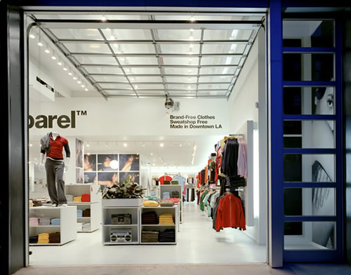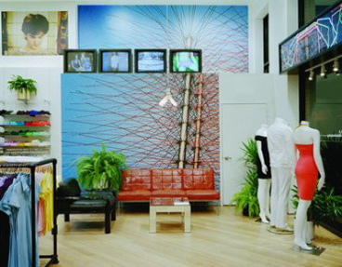
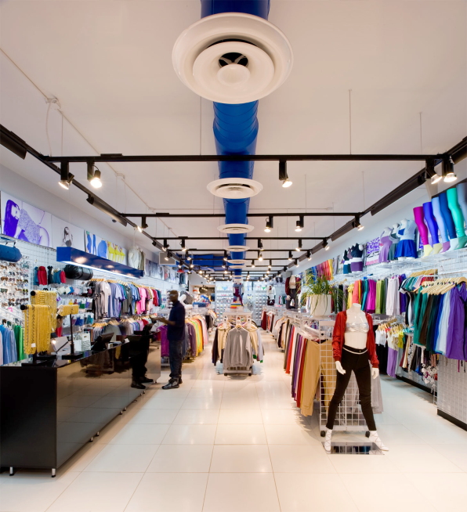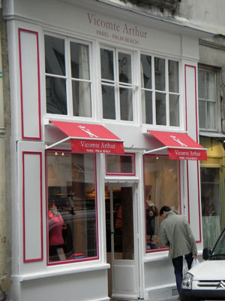
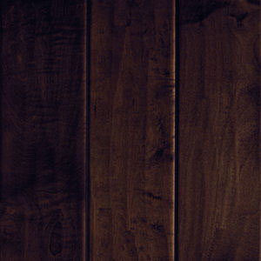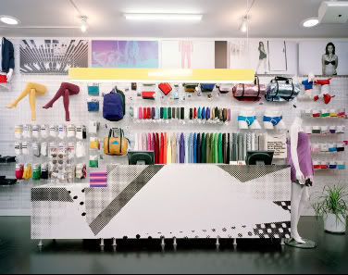
FITTING ROOMS
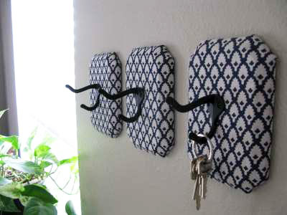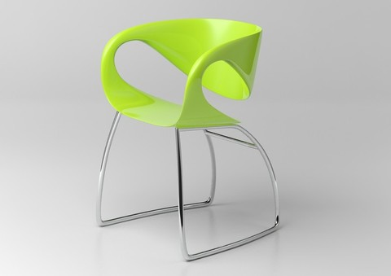
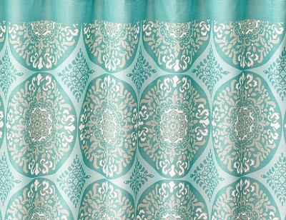
LIGHTING
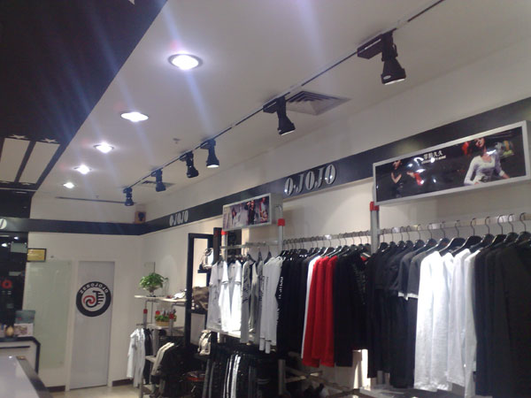
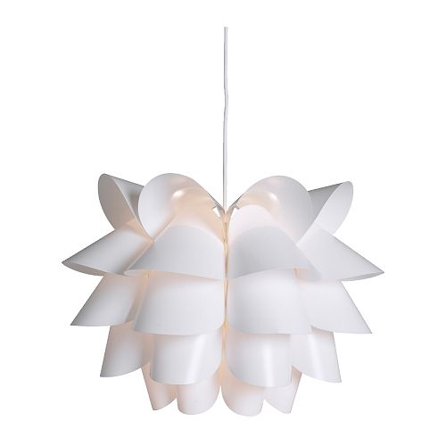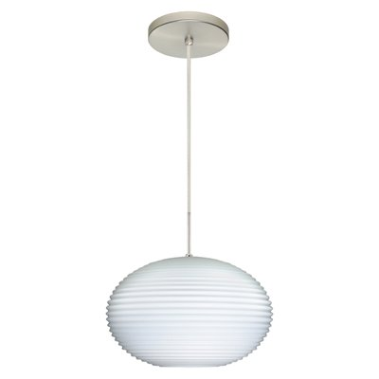

FURNITURE
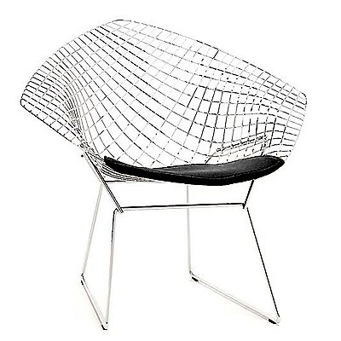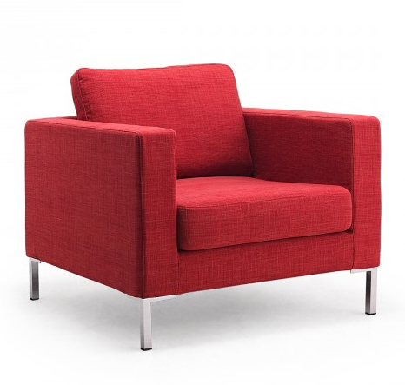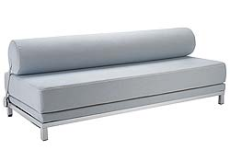
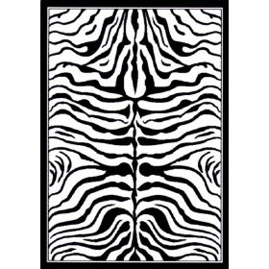
MERCHANDISE FIXTURES

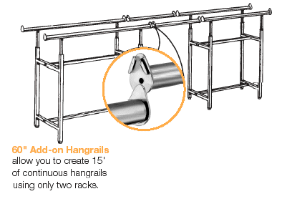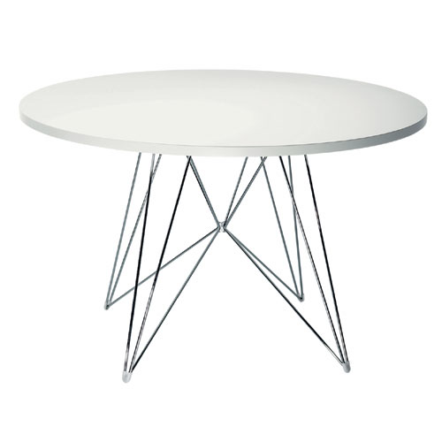
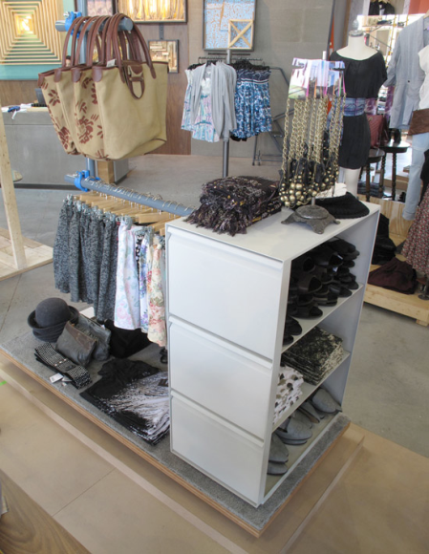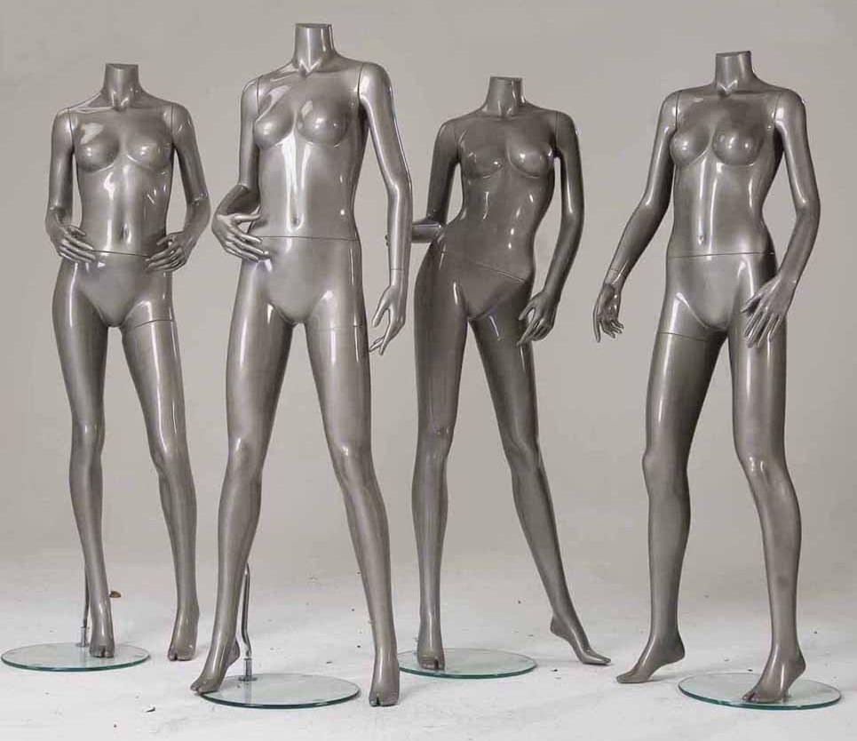
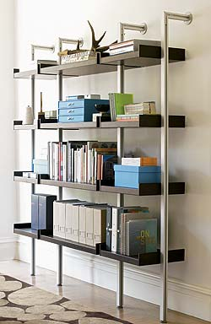
IMAGES FROM LOCATION

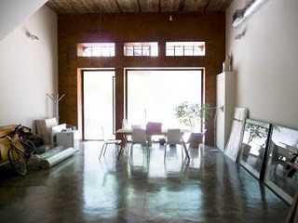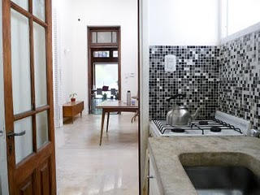
Main selling space View from break room to back room
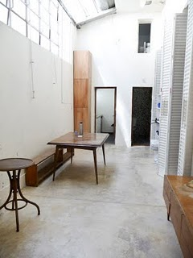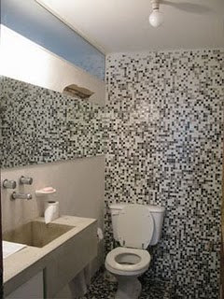
Back room/storage space Restroom for employees and customers
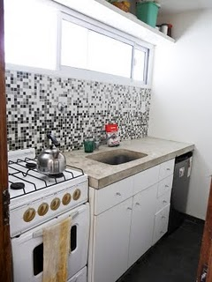 Kitchen/break room for employees
INTERIOR FLOOR PLAN
- Back room
10.

3.

4. 4.

8.

4. 4. 11.

8.
12.

121212.1.
6.
5.
1.
2.
2.
2.

7.
9.
- Fitting rooms
- Seating area
- Straight wall rack
- Kitchen/break room
- Restroom
- Indoor patio
- Mannequins
- Cash wrap
- Round display table
- Straight racks
- Store entrance

