
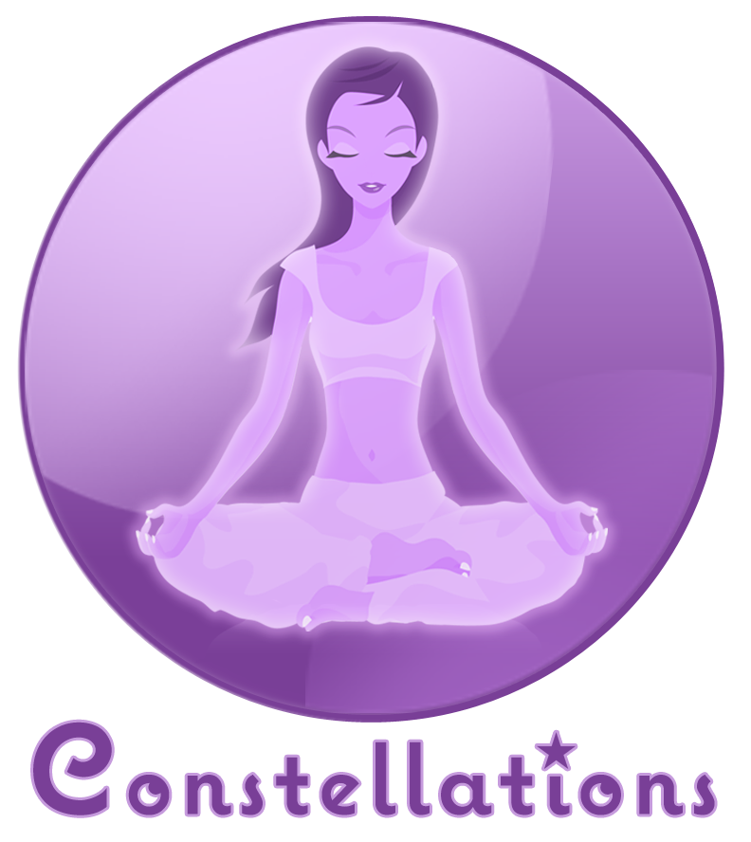

One Earth,

One You.

So, join us for an Earth Day Celebration underneath the stars

Constellationsfitness.com

ou.
Enjoy complimentary cocktails from Organic Earth, live music by She Mob, and yoga under the stars!
Constellations,
1355 Grant Ave.
San Francisco 94133
20% Off
Merchandise
April 24, 2010
7-11PM

